Project Scope: Customer Analytics in Retail Phase 1 and 2

Objectives:

  - Analyze sales performance-Overall and By Products
  - Study customer buying behavior and create customer segments
  - Develop Campaign Response Model –Use traditional and ML algorithms
  - Perform Sentiment Analysis of Customer Feedback
  - Develop Web Application/Dashboard

GitHub repository:
https://github.com/emmanuelogbonna/AIML-Retail-Campaign-Project
The repository contains the project notebook, README, and supporting project files.

Phase 1 is all about data management

- Understand two data sets: 1) Transaction Data- Year 2023 2) Campaign Data-Jan 2024
(understand variables, data dimension, unexpected values (ex: negative values in quantity), Check duplicate records if any etc.)
Understanding the variables
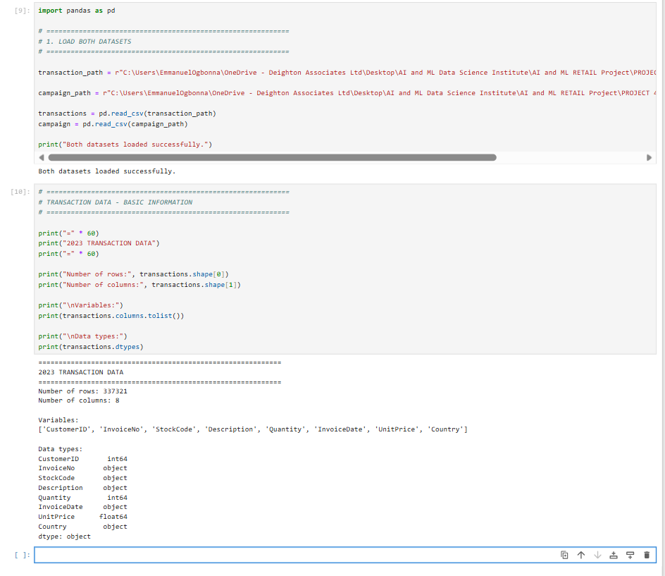
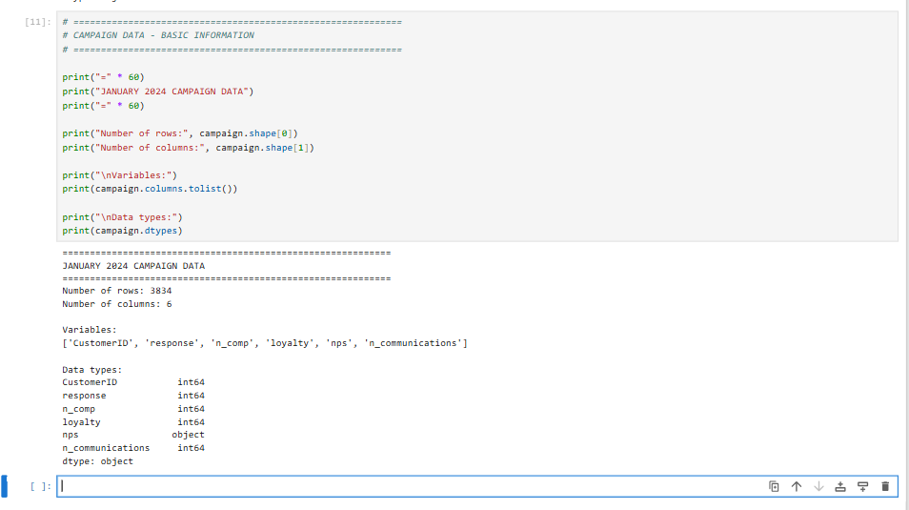
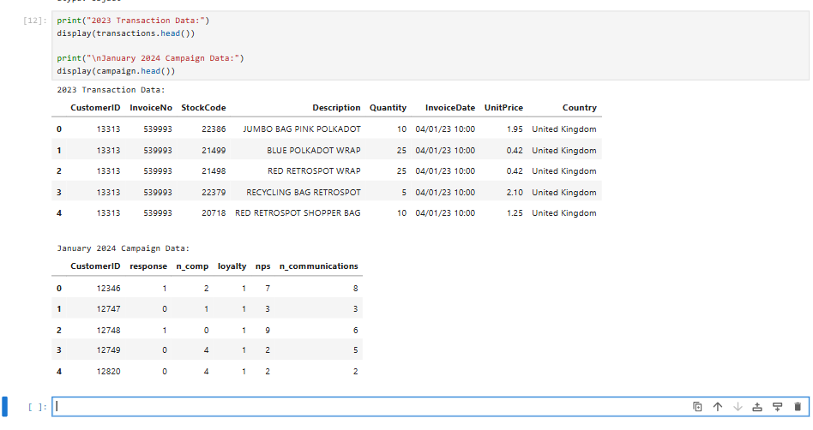
Duplicate records
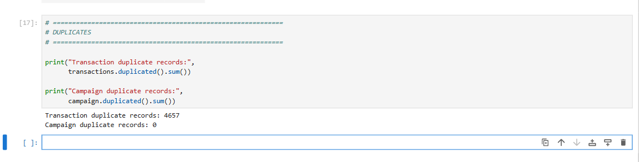
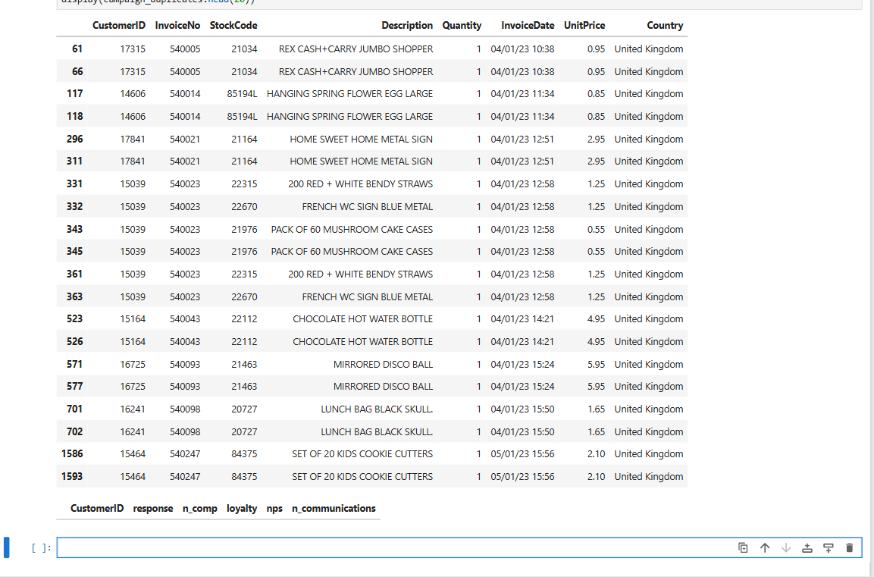
Checking the Negative Quantity values.
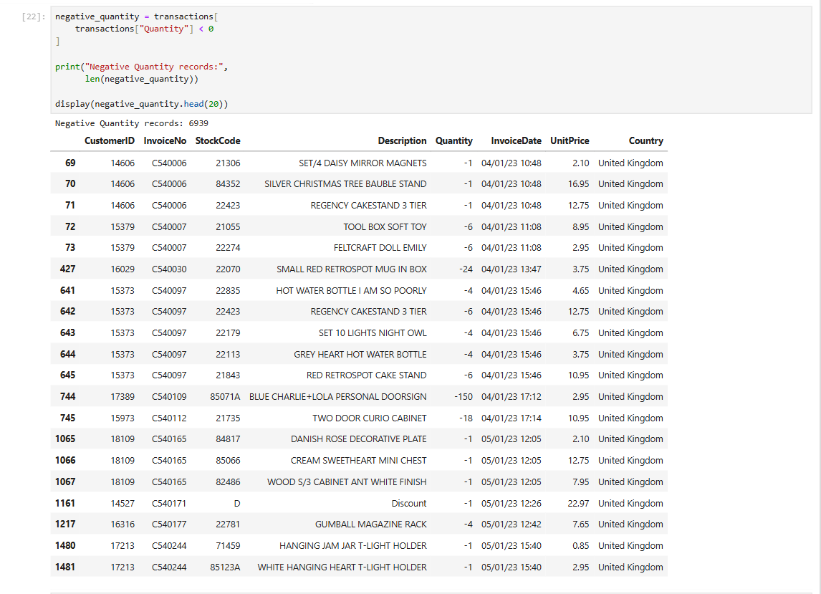

Checking the variables such as Response, Loyalty, and NPS
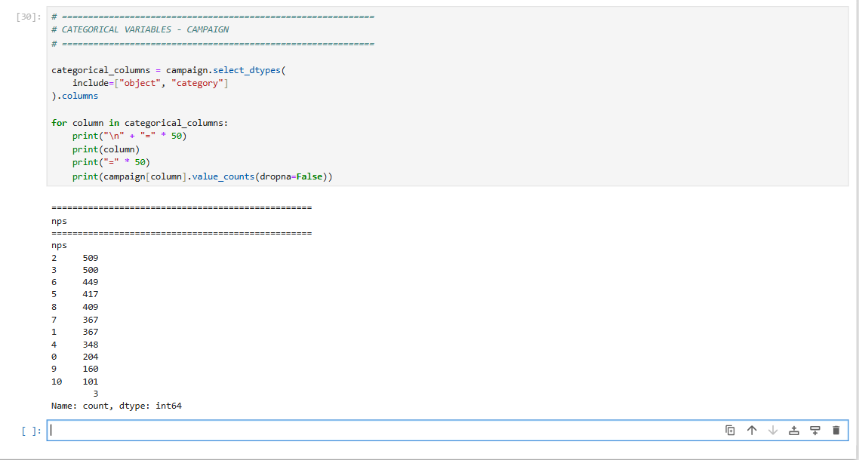
Response
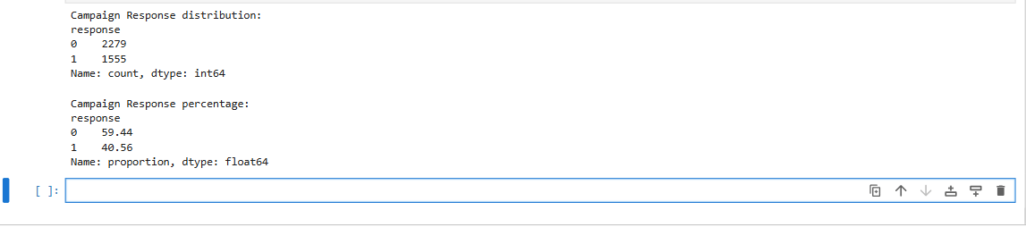
Nps
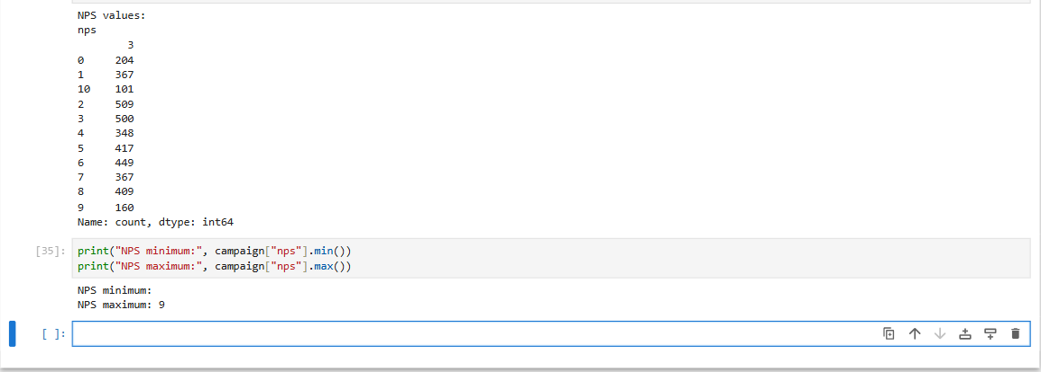
Summary
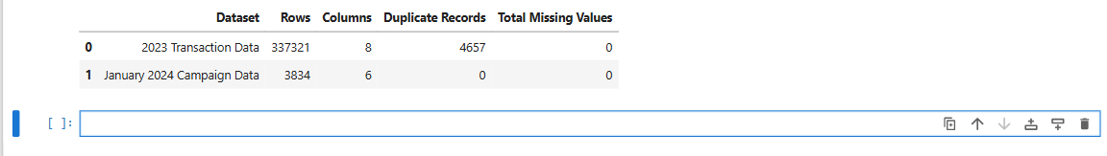

- Derive total sales for each customer (feature 1)
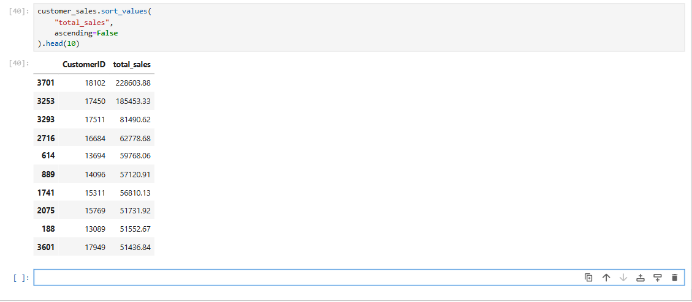

- Derive number of unique products purchased by each customer (feature 2)
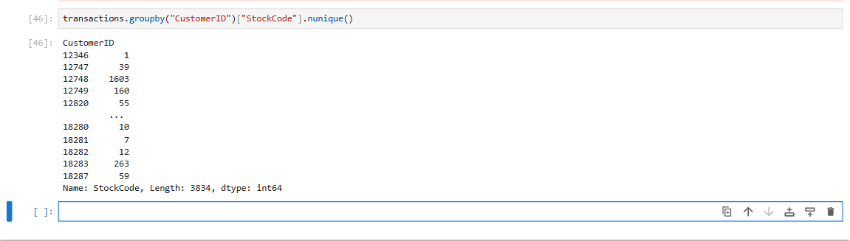

- Derive number of invoices generated by each customer (feature 3)/Or Number of days purchased

Number of Invoices created by each customer
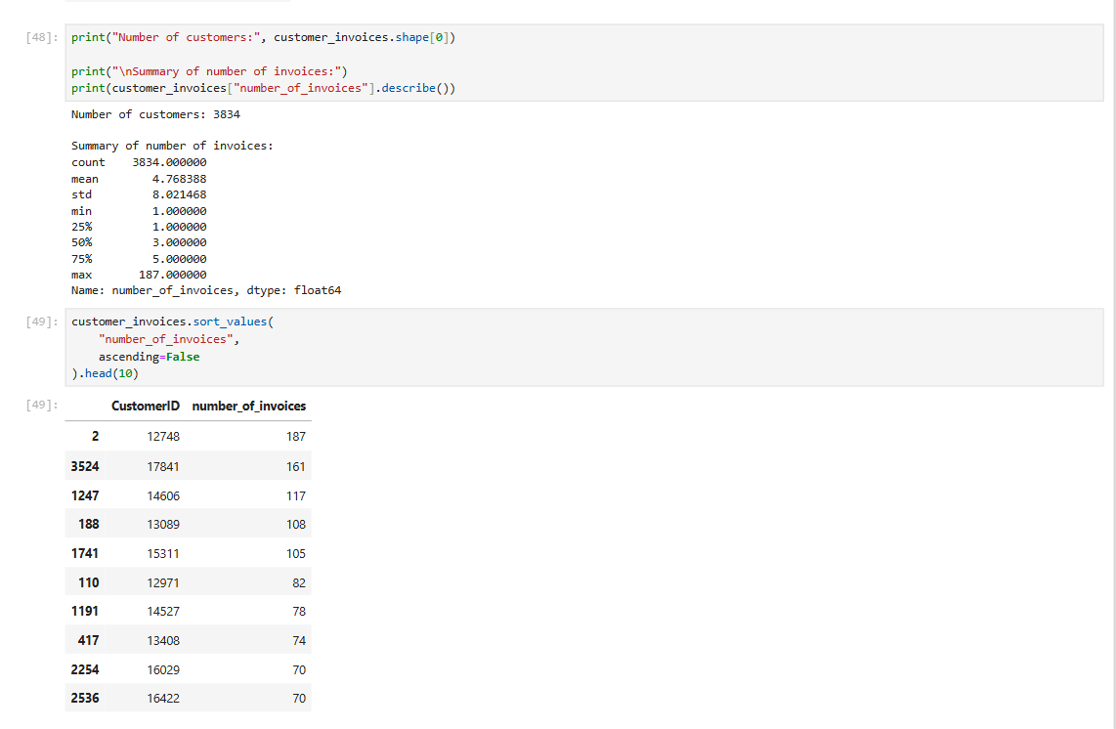
Additional features Total Sales, Number of Invoices, Purchase Days, average_invoice_value, average_quantity_per_invoice, average_product_price customer_lifetime_days.
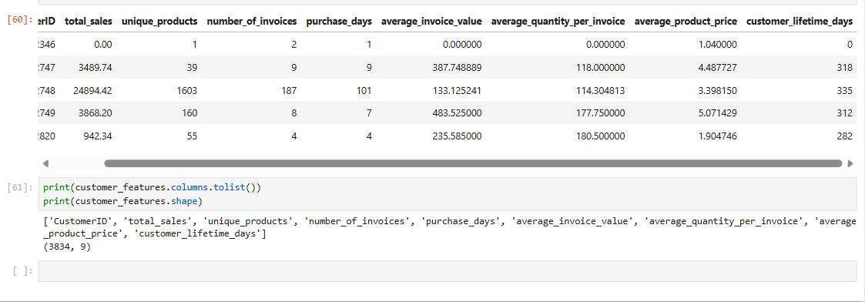

- Merge new features with campaign response data -Create a master data for campaign response model
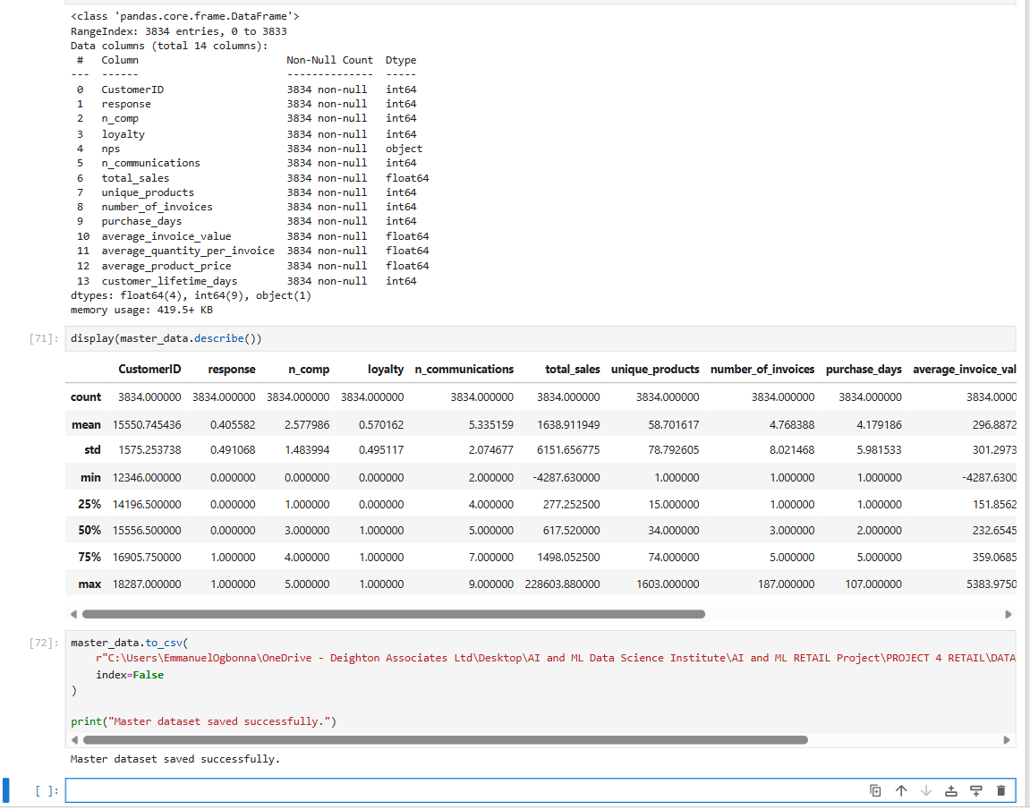

- Check each numerical variable for possible recoding into categorical variable (commonly done in modeling)
Full Distribution list
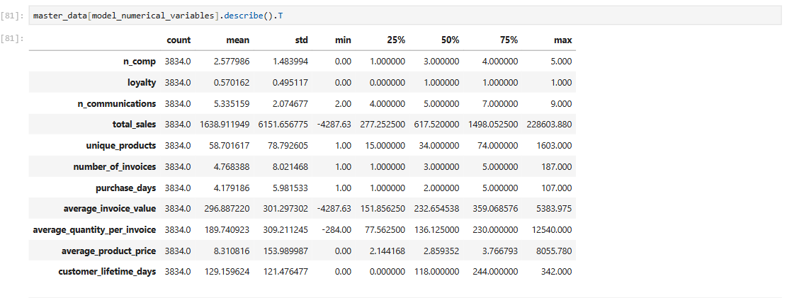
The Unique Values
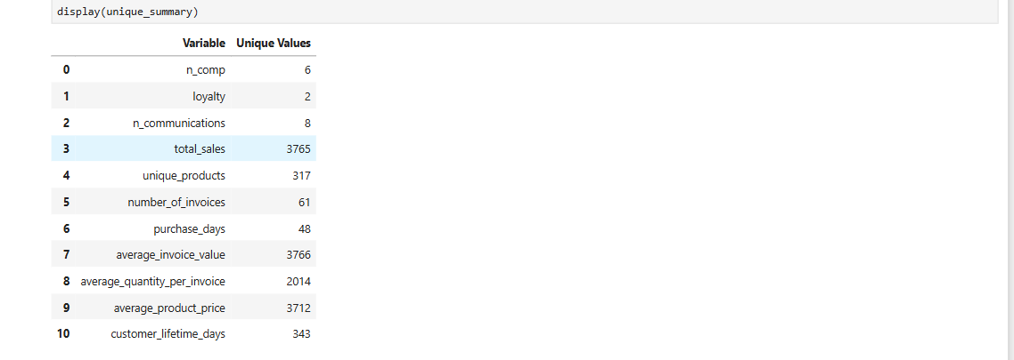
Loyalty Variable
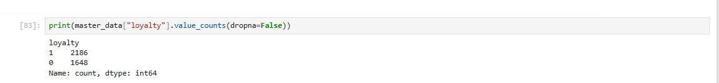
NPS
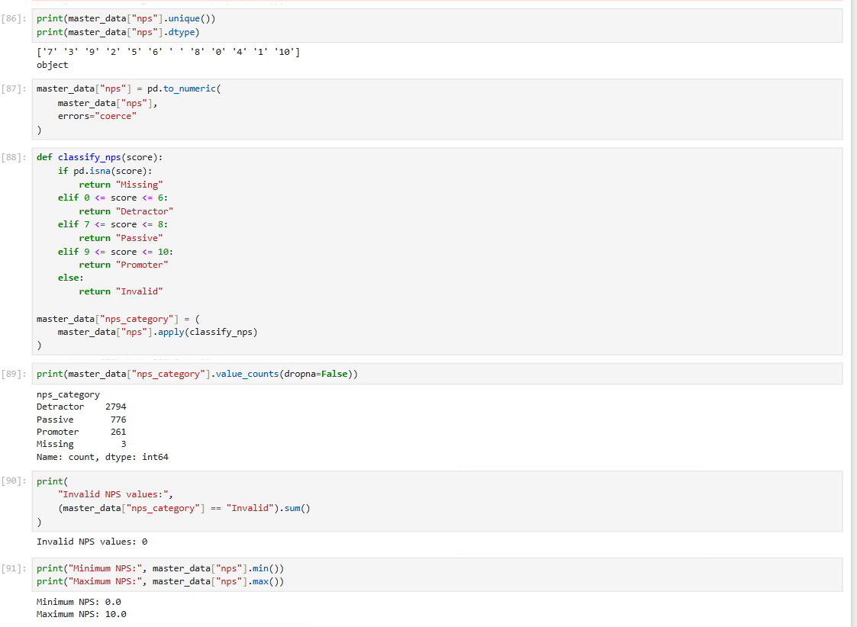

N Comp displaying the number of campaign and contracts
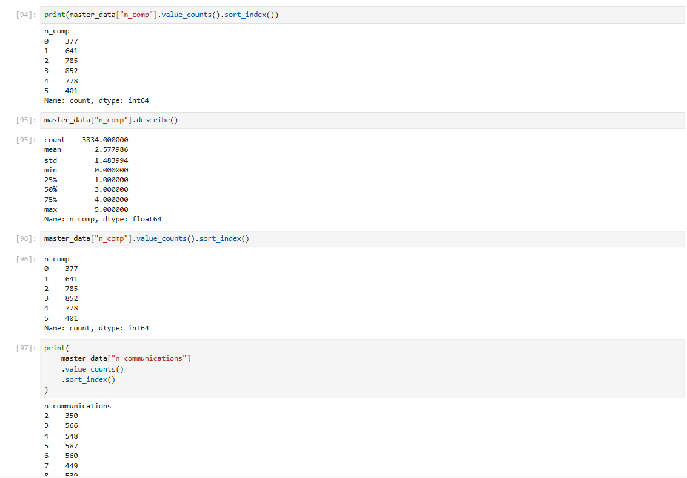

- Obtain overall campaign response rate
The overall campaign response rate is 40.56%.
Out of 3,834 customers targeted by the campaign, 1,555 customers responded and 2,279 did not respond.
The overall campaign response rate was therefore 40.56%, with a non-response rate of 59.44%.

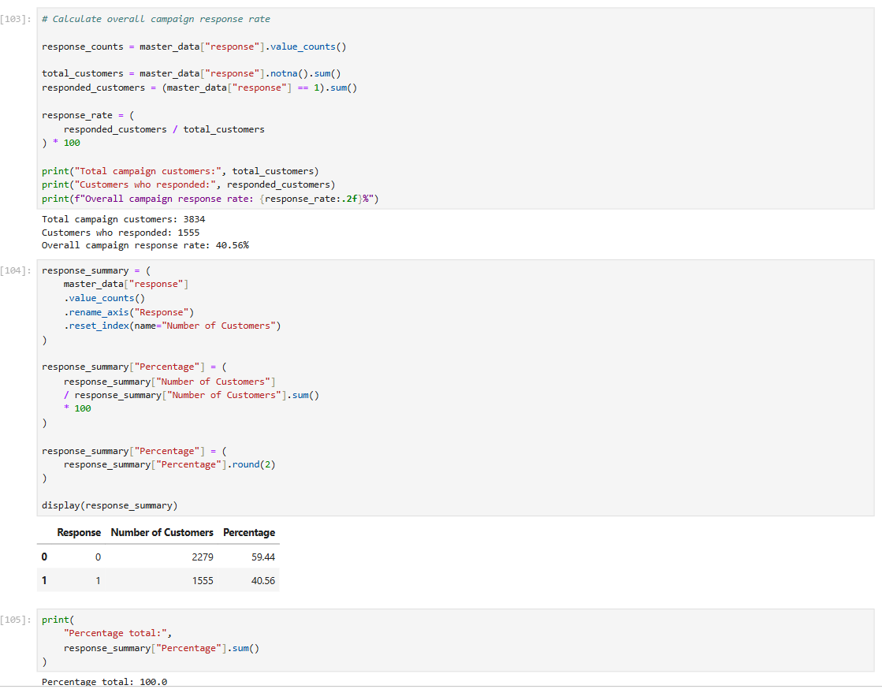

Phase 2 is about data analysis using graphs, tables etc (EDA)

The objective of phase 2 is to relate “Response” with other variables in the data. These insights will be useful prior to modeling in which you will take all variables together and model “Response” in phase 3
In addition, transaction data can be analysed to identify trend in month on month sales and find top products.

- Box-Whisker plot for variable NPS by “Response”.

This can be done for n_comp and n_communications.
NPS Campaign Response
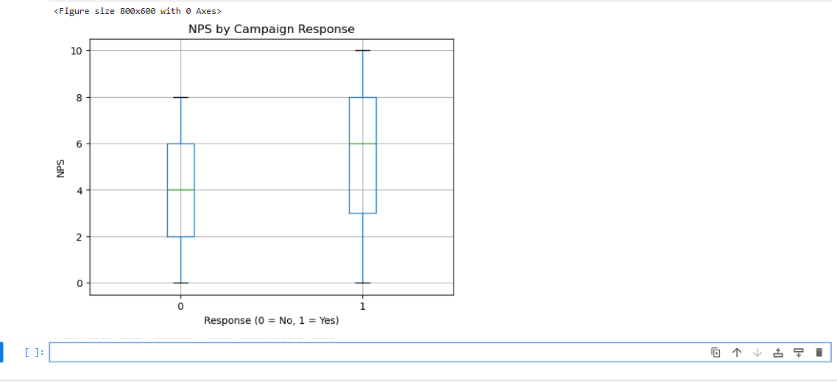
N_Comp Campaign Response
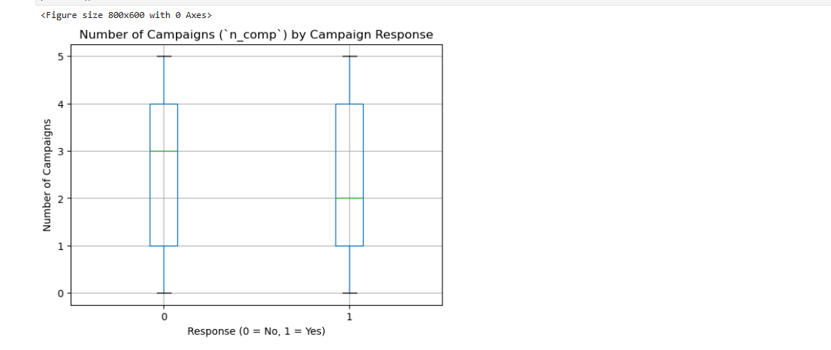

Communications by Campaign Response
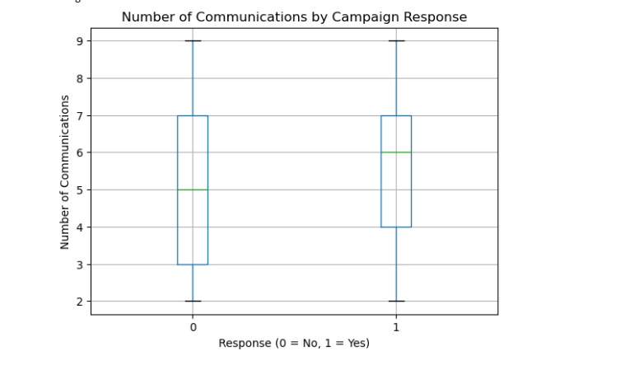
The statistical numbers behind the boxplot Median and Mean summary
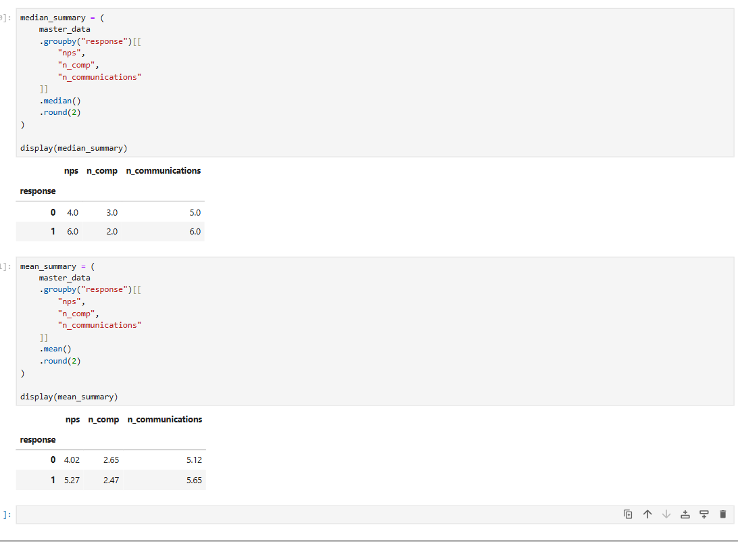

Summary
The box-whisker analysis indicates that NPS has the clearest difference between responders and non-responders.
Responders have substantially higher median NPS 6 against 4 and higher mean NPS 5.27 against 4.02.
N_Communications also shows a modest positive association with response, with responders having a median of 6 communications compared with 5 for non-responders.
In contrast n_comp shows very little difference with responders having a slightly lower mean and median number of previous campaigns.

- Table of Response Rate:

Loyalty | N | N+ | RR=(N+/N)*100
0 | 700 | 325
1 | 528 | 188

Same can be done for 3 categories of NPS- Detractor (0-6),Passive(7-8) And Promoter(9-10)
NPS Catergory
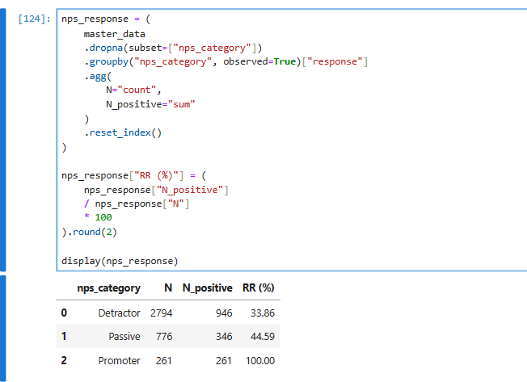
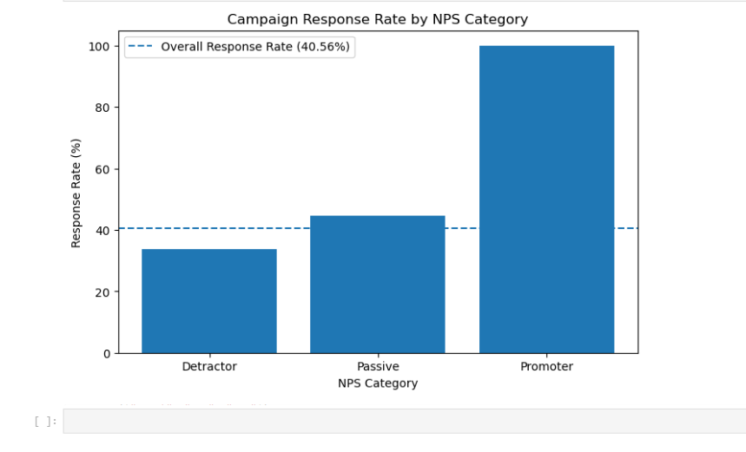
Individual NPS score (0-10) where the 100% Promoter response rate is from
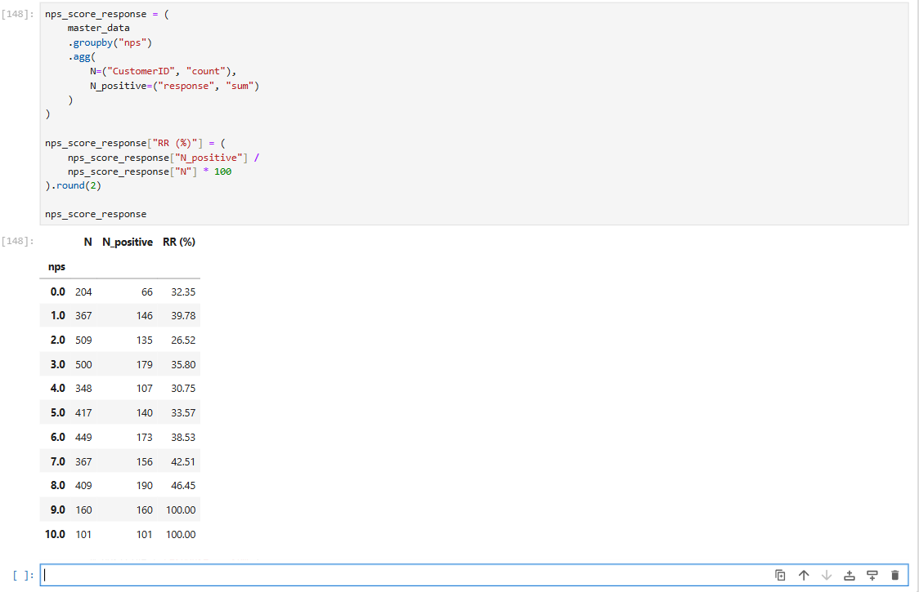
100% Promoter response rate is driven by the NPS scores 9 and 10.
Every customer with NPS = 9, 160/160 responded and Every customer with NPS =10, 101/101 responded. This indicates the potential response bias, where highly satisfied customers disproportionately represented among campaign respondents.

- Bar Chart:

Mean or median for feature1/2/3 for response=0 and 1
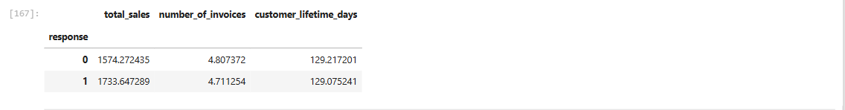
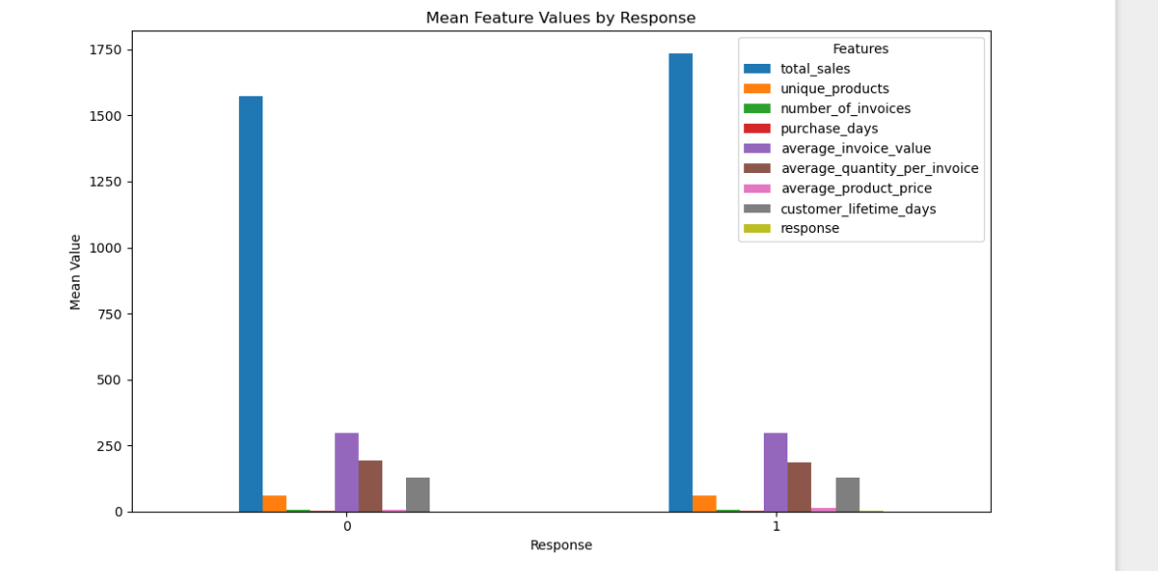

Then obtain Bar Chart.( X axis will have response 0 and 1)
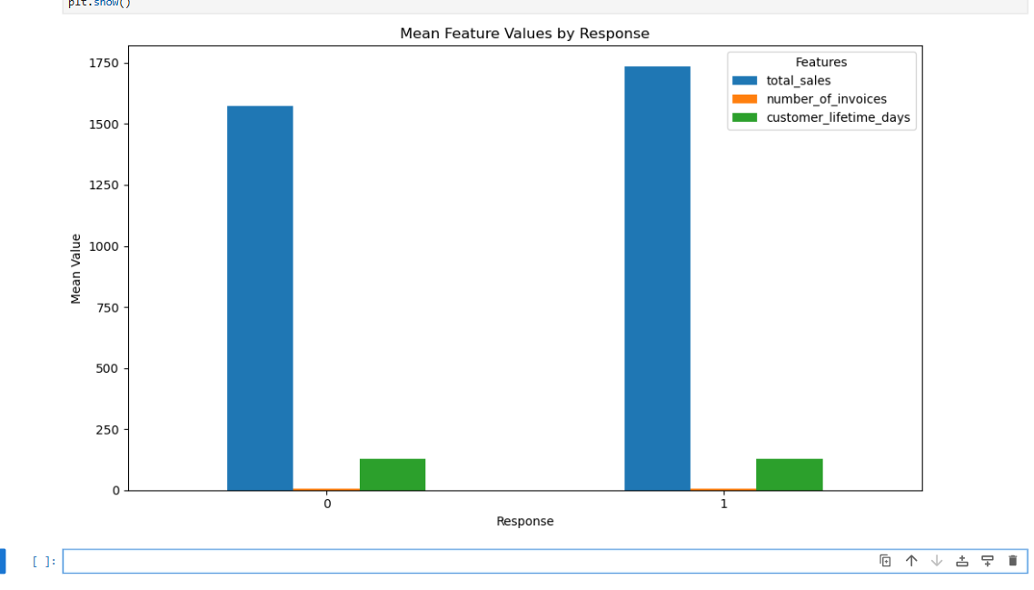

Note: Students can think of different types of tables and graphs for EDA

Bar Chart: Mean or median for feature1/2/3 for response = 0 and 1.
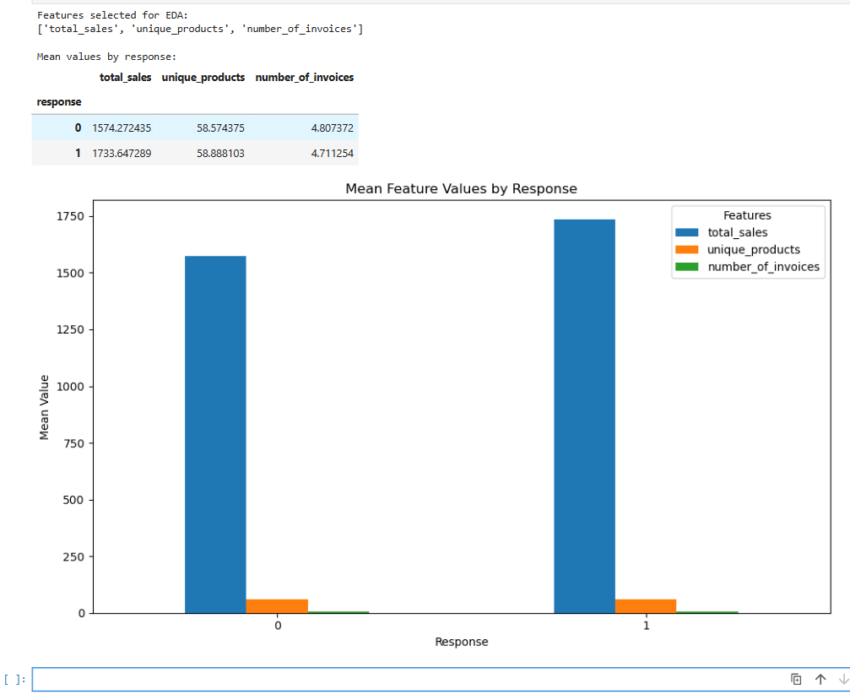

Response-rate charts for Campaign response
